**CIS 375 – Fall 2019 Term Project - BRAINS**

Use Case Specification Document

**3**

**Question Maintenance**

**Version No. 1.0.0**

Project Document Revision History

|  |  |  |  |
| --- | --- | --- | --- |
| VersionNumber | Date | Revision Author | Description of Revision |
| 1.0.0 | 10/28/2019 | Mostafa ELMajzoub | Creation of document. |
|  |  |  |  |

|  |
| --- |
| **Table of Contents** |

1. Introduction 4

2. Use Case Information 4

2.1 Actors 4

2.2 Use Case Interaction 4

3. Trigger 5

4. Pre-condition(s) 5

4.1 A Department and department users has already been created to answer the questions 5

5. Post-condition(s) 5

5.1 Questions are modified 5

5.2 Questions are added 5

5.3 Questions are removed 5

5.4 Help feature is added 5

5.5 Help feature is removed 5

6. Use Case Swimlane (Activity) Diagram 5

7. Main/Basic Flow(s) of Events (Happy Path) 6

7.1 Question is removed 6

7.2 Question is added 6

7.3 Question is modified 6

7.4 Help button is added 6

7.5 Help button is modified 6

7.6 Question is answered 6

8. Alternate/Exception Flow of Events 6

8.1 Departments provide feedback 6

9. Assumptions/Business Rules including Non-Functional Requirements 6

10. Use Case Specification Review and Signoff 7

# Introduction

This document captures detailed functional and non-functional BUSINESS requirements. Technical or application IT requirements should not be detailed here. A separate Use Case Summary document ties ALL the individual use cases together. First create the Use Case Summary document using application decomposition. Then increase the detail by creating the individual use case specifications – be careful not to create too many or not create enough use cases.

Write a single paragraph describing the purpose of the specific use case in the Introduction.

This use case is for adding, removing, or modification of questions done by the Oversight Team as well as providing a help button feature that allows the Oversight team to Clarify on the questions asked as they see fit. The questions get sent to Departments for answering. This is Use Case 3, with the Oversight Team as the main actor and the Departments as the secondary actor.

# Use Case Information

## Actors

An actor is someone or something (e.g. application system) outside the system or business that interacts with the application. For every Use Case, there must be at least one Main Actor and zero or more Secondary Actors. Actors should be a person, system, or time.

|  |  |  |
| --- | --- | --- |
| Actor Name | Role | Description |
| Oversight Team | Main | Can create, remove, update, and modify the questions as well as the help button feature. |
| Departments | Secondary | Answer the questions and provide feedback to the oversight team if they anything that they are uncertain of. |

## Use Case Interaction

How does this use case relate to other uses cases? List predecessor and successor use cases.

Predecessors:

1. Use case 6: ~
   1. Users and departments are created to answer the questions and modify them as needed.

Successors:

1. Use case 1: ~
   1. Departments answer the questions
   2. Provide feedback in necessary.
2. Use case 5: ~
   1. Questions can be updated and reviewed by the oversight team.
   2. Then they determine if they reject, remove, or approve the submissions

Purgatory:

1. Use case 1: ~
   1. this use case, it is a subset of this use case in terms of Departments answering questions and providing feedback if necessary.

# Trigger

What causes the use case to initiate?

When there is an update to the rules and regulations and if there is an error detected or something is not clear pointed out by the Departments.

# Pre-condition(s)

What use cases or other pre-conditions must be met before use can initiate?

## A Department and department users has already been created to answer the questions

# Post-condition(s)

What are ALL the possible output states upon completion of the use case flows?

## Questions are modified

## Questions are added

## Questions are removed

## Help feature is added

## Help feature is removed

# Use Case Swimlane (Activity) Diagram

Draw diagram(s) that cover ALL main and alternate flows.

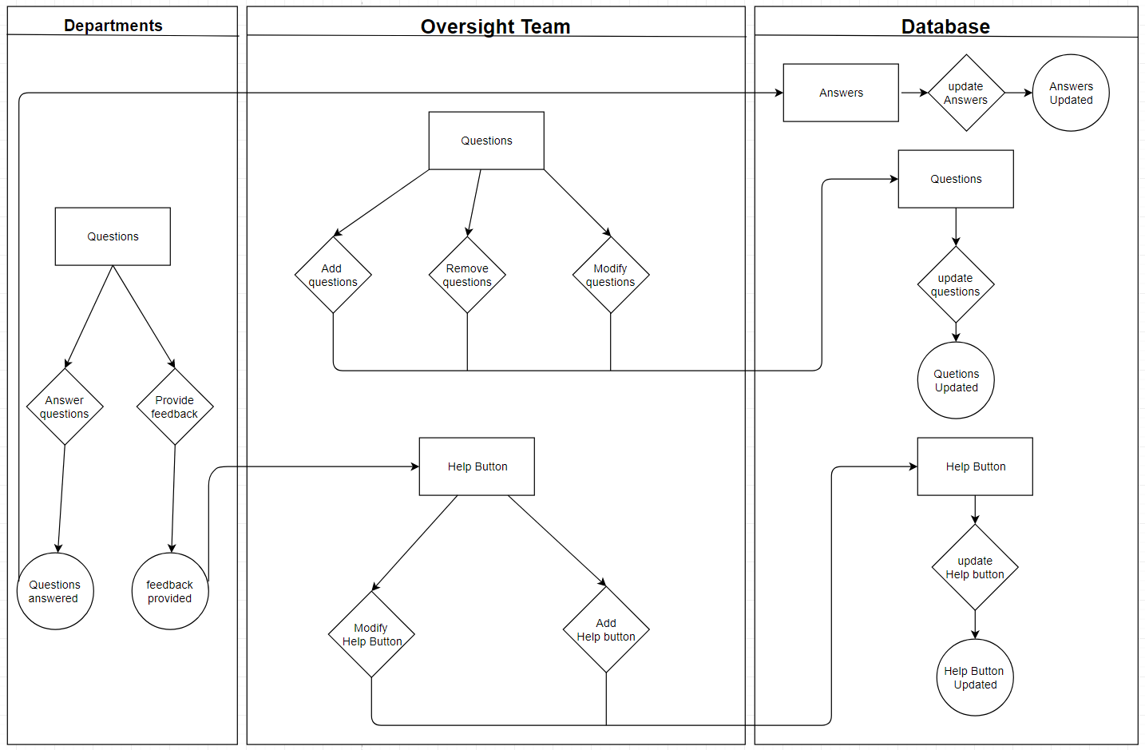

# Main/Basic Flow(s) of Events (Happy Path)

For each main flow (usually ONE flow) write the list of steps that occur – describe WHAT occurs not HOW to do it!

## Question is removed

* Oversight team removes questions as necessary and the Database updates it

## Question is added

* Oversight team adds questions as necessary and the Database updates it

## Question is modified

* Oversight team modifies questions as necessary and the Database updates it

## Help button is added

* Oversight team adds help button as necessary and the Database updates it

## Help button is modified

* Oversight team modifies help button as necessary and the Database updates it

## Question is answered

* Departments answer questions and the Database updates it.

# Alternate/Exception Flow of Events

For each alternative flow (can be zero or more) write the list of steps that occur – describe WHAT occurs not HOW to do it!

## Departments provide feedback

* Departments provide feedback about a question so that Oversight Team modifies the help button and the server updates.

# Assumptions/Business Rules including Non-Functional Requirements

Be sure to number the assumption/business rules to allow easy reference to them. Business rules will be where non-functional requirements are recorded – have a way to specifically identify non-functional requirements.

# Use Case Specification Review and Signoff

|  |  |  |  |  |
| --- | --- | --- | --- | --- |
| Review and Signoff of the Use Case Specification | | | | |
| Name | Project Team Role | Signature | Date |
| Ahmed, Zakariya | Senior Tech Lead/SPMP manager |  | 10/28/19 |
| Alhaidar, Muaz | Developer |  | 10/28/19 |
| Longworth, Kevin | Developer |  | 10/28/19 |
| Labut, Cameron | Developer |  | 10/28/19 |
| Majzoub, Mostafa El | Developer | M.M. | 10/28/19 |

# 